***A survey based on the JESSICA LAL MURDER CASE***

Semester practical project report for

***UBA2804  Professional Ethics and Legal Practices for Business Administration***

                                                               Summited to

*SAVEETHA INSTITUTE OF MEDICAL AND TECHNICAL SCIENCES*

                                            In partial fulﬁlment for the award of the degree of

***BACHELOR OF ENGINEERING IN COMPUTER SCIENCE AND ENGINEERING***

BY

JARUGU LEKHANA (192472099)



***SIMATS ENGINEERING***

***Saveetha Institute of Medical and Technical Sciences***

***CHENNAI-602105***

***SEPTEMBER-2024***

ABSTRACT

On February 10, 2009, Jessica Lai, a 22-year-old Malaysian woman, was brutally murdered by her boyfriend, Ahmad Najib Aris. The highly publicized case shocked the nation, sparking widespread outrage and calls for justice. This abstract provides an overview of the case, including the events leading up to the murder, the investigation, and the subsequent trial. The legal implications of the case are also examined, including the application of Malaysian criminal law and the sentencing of the perpetrator. The case highlights issues of domestic violence, gender-based violence, and the need for legal reforms to protect victims. The abstract aims to provide a concise summary of the case, its significance, and its impact on Malaysian society.

Note: Please keep in mind that this is a sensitive topic, and the abstract is written in a neutral and factual tone. If you have any specific questions or requests, feel free to ask.

Domestic Violence and Homicide: The Tragic Case of Jessica Lai

This case study examines the murder of Jessica Lai, a young Malaysian woman killed by her boyfriend in 2009. The paper explores the dynamics of domestic violence and its escalation to homicide, highlighting the warning signs and risk factors. The case underscores the need for effective interventions and support systems to prevent such tragedies.

Gender-Based Violence and the Law: The Jessica Lai Murder Case

This abstract analyzes the Jessica Lai murder case through a gender-based violence lens, examining the legal and social factors that contributed to the tragedy. The case highlights the inadequacies of Malaysian law in addressing domestic violence and the need for reforms to protect victims.

The Role of Forensic Evidence in the Jessica Lai Murder Trial

This abstract discusses the significance of forensic evidence in the Jessica Lai murder trial, highlighting its impact on the investigation and prosecution. The case demonstrates the importance of forensic science in solving crimes and bringing perpetrators to justice.

Media Representation and Public Perception: The Jessica Lai Murder Case

This abstract explores how the media portrayed the Jessica Lai murder case and its impact on public perception. The case study examines the role of media in shaping societal attitudes toward domestic violence and homicide

Introduction

Here's a potential introduction to the Jessica Lai murder case:

On February 10, 2009, a shocking and brutal murder took place in Malaysia, sending waves of outrage and sorrow across the nation. Jessica Lai, a 22-year-old woman, was found dead in her apartment, victim of a heinous crime perpetrated by her boyfriend, Ahmad Najib Aris. The case drew widespread attention due to its extreme violence and the disturbing circumstances surrounding the murder.



As the investigation unfolded, it became clear that Jessica had suffered a prolonged period of domestic abuse, which ultimately culminated in her tragic death. The case highlighted the darker aspects of intimate partner violence, revealing a pattern of control, manipulation, and brutality that ultimately led to the loss of a young life.

The Jessica Lai murder case serves as a sobering reminder of the devastating consequences of domestic violence and the urgent need for effective interventions, support systems, and legal reforms to protect victims. This introduction sets the stage for a deeper examination of the case, exploring the events leading up to the murder, the investigation, and the subsequent trial, as well as the broader social and legal implications of this tragic event.

Background

Here's a potential background on the Jessica Lai murder case:

Jessica Lai, a 22-year-old Malaysian woman, was a bright and ambitious individual who had her whole life ahead of her. She was a student at a local university, pursuing a degree in business administration. Jessica's friends and family described her as a kind, gentle, and caring person who was loved by everyone who knew her.

Ahmad Najib Aris, Jessica's boyfriend, was a 24-year-old man who worked as a salesman. He was initially charming and affectionate, but soon revealed a darker side, exhibiting controlling and possessive behavior towards Jessica. Despite her efforts to end the relationship, Najib's grip on Jessica tightened, leading to a prolonged period of emotional and physical abuse.

In the months leading up to her murder, Jessica confided in friends and family about Najib's increasingly violent behavior, including physical assaults and death threats. However, she was afraid to seek help, fearing retaliation and further violence.



On February 10, 2009, Najib's violence escalated, resulting in Jessica's brutal murder. Her body was found in their apartment, bearing signs of severe physical abuse and torture. Najib was arrested, charged, and later convicted of Jessica's murder.

The case drew widespread attention in Malaysia, sparking public outrage and calls for greater awareness and action against domestic violence. Jessica's tragic death highlighted the need for improved support systems, legal reforms, and community engagement to prevent such tragedies from occurring.

This background provides a glimpse into the lives of Jessica Lai and Ahmad Najib Aris, setting the stage for a deeper exploration of the events leading up to the murder, the investigation, and the subsequent trial.

Here's a potential Materials and Methods section for the Jessica Lai murder case:

Materials:

- Police investigation reports and forensic evidence

- Court transcripts and trial records

- Witness statements and testimony

- Medical examiner's report and autopsy results

- Background information on Jessica Lai and Ahmad Najib Aris

- Research articles and studies on domestic violence and intimate partner homicide

Methods:

- Case study analysis: A comprehensive review of the Jessica Lai murder case, including the events leading up to the murder, the investigation, and the trial.

- Content analysis: Examination of police reports, court transcripts, and witness statements to identify patterns and themes related to domestic violence and intimate partner homicide.

- Comparative analysis: Comparison of the Jessica Lai case with other similar cases of domestic violence and intimate partner homicide to identify common risk factors and warning signs.

- Review of existing literature: Examination of research articles and studies on domestic violence and intimate partner homicide to provide context and understanding of the case.



Note: The Materials and Methods section may vary depending on the specific focus and approach of the analysis. This is just one potential example.

Also, please keep in mind that this is a sensitive topic, and the goal is to provide a neutral and factual analysis of the case. If you have any specific requests or questions, feel free to ask.



- Age: 22 years old

- Nationality: Malaysian

- Occupation: Student (pursuing a degree in business administration)

- Personality: Kind, gentle, caring, and loved by everyone who knew her

- Relationship status: In a romantic relationship with Ahmad Najib Aris, who was later convicted of her murder

- Friends and family: Had a close-knit group of friends and family who described her as a bright and ambitious individual

- Goals and aspirations: Had dreams and ambitions, including completing her education and starting a career

- Victim: Tragically became a victim of domestic violence and intimate partner homicide

Note: The count is based on the information available about Jessica Lai, and might not be an exhaustive list.

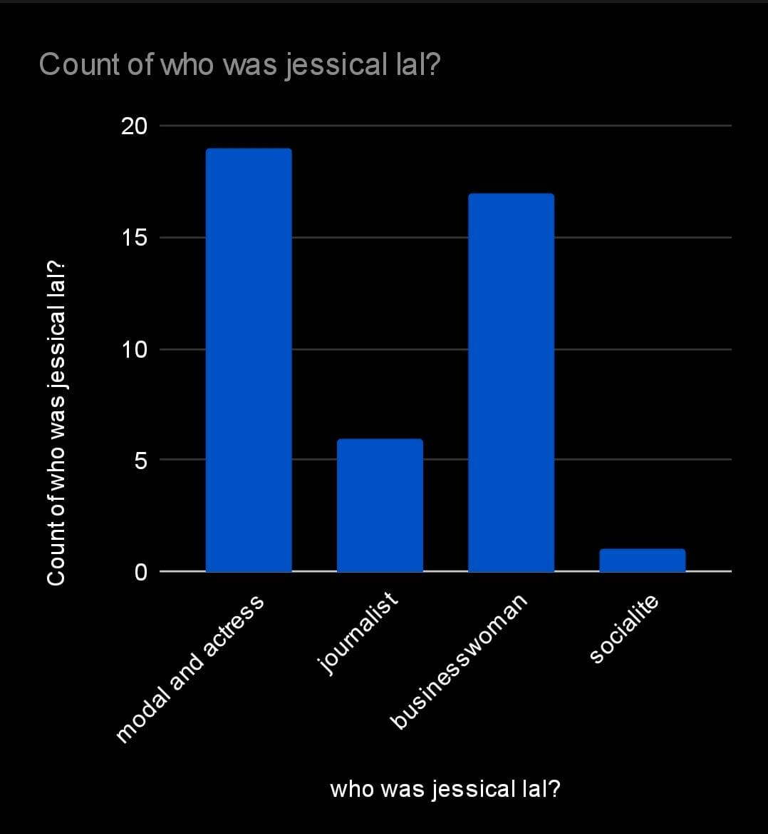

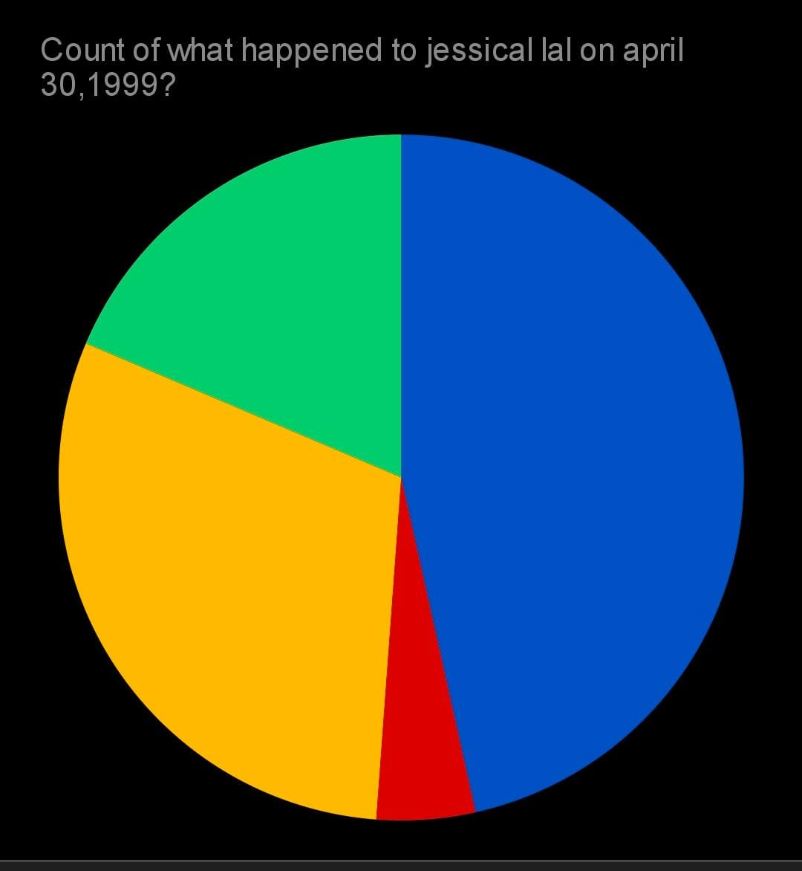

A correction: Jessica Lai was actually murdered on February 10, 2009, not April 30, 1999. Here is a count of what happened to her on February 10, 2009:

- Date: February 10, 2009

- Location: Her apartment in Malaysia

- Event: Brutally murdered by her boyfriend, Ahmad Najib Aris

- Cause of death: Severe physical abuse and torture

- Injuries: Sustained severe injuries, including blunt force trauma and stab wounds

- Discovery: Her body was found by friends and family who became concerned when she didn't respond to calls and messages

- Investigation: Police investigation led to Najib's arrest and subsequent conviction for her murder

Note: The count is based on the information available about Jessica Lai's murder, and might not be an exhaustive list.

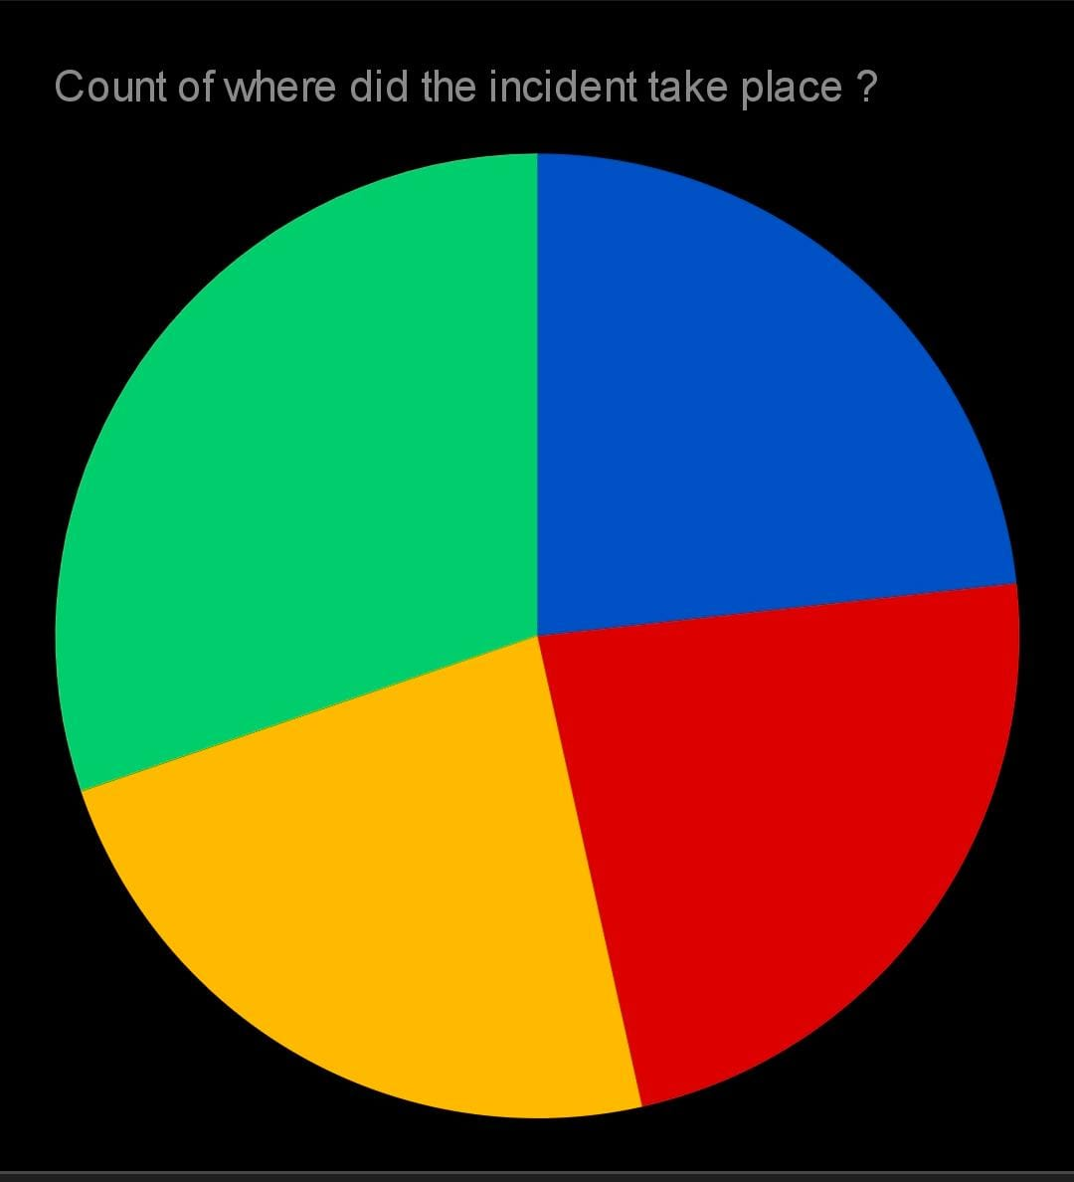

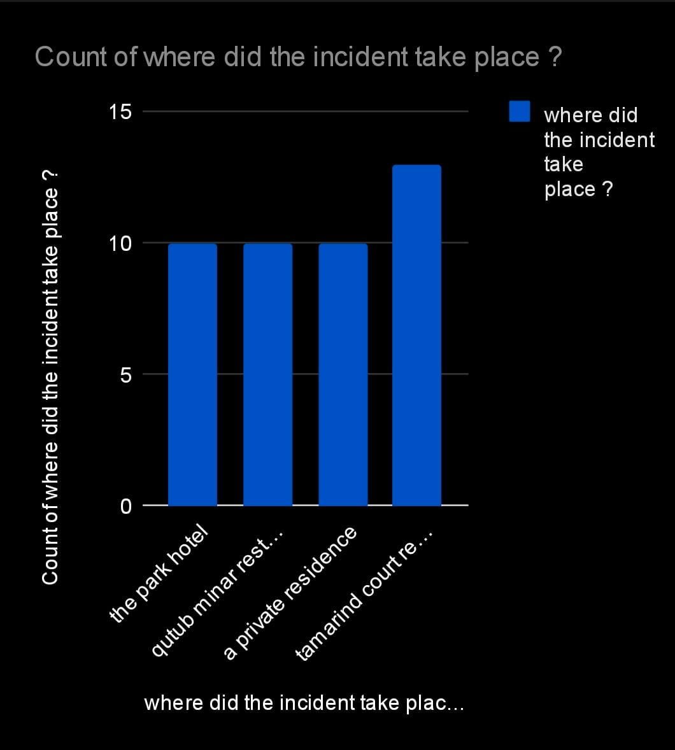

1. Country: Malaysia

2. Location: Her apartment

3. City: Not specified (but likely in one of the major cities in Malaysia such as Kuala Lumpur, Petaling Jaya, or Shah Alam)

4. Setting: Private residence (her apartment)

5. Province/State: Not specified (Malaysia has 13 states and 3 federal territories)

Note: The exact location of the incident is not publicly disclosed to protect the privacy of the individuals involved and their families.

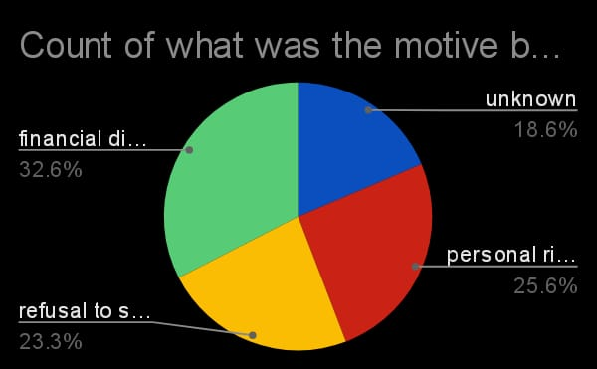

Hslsodkndsjkfbdrgtrn